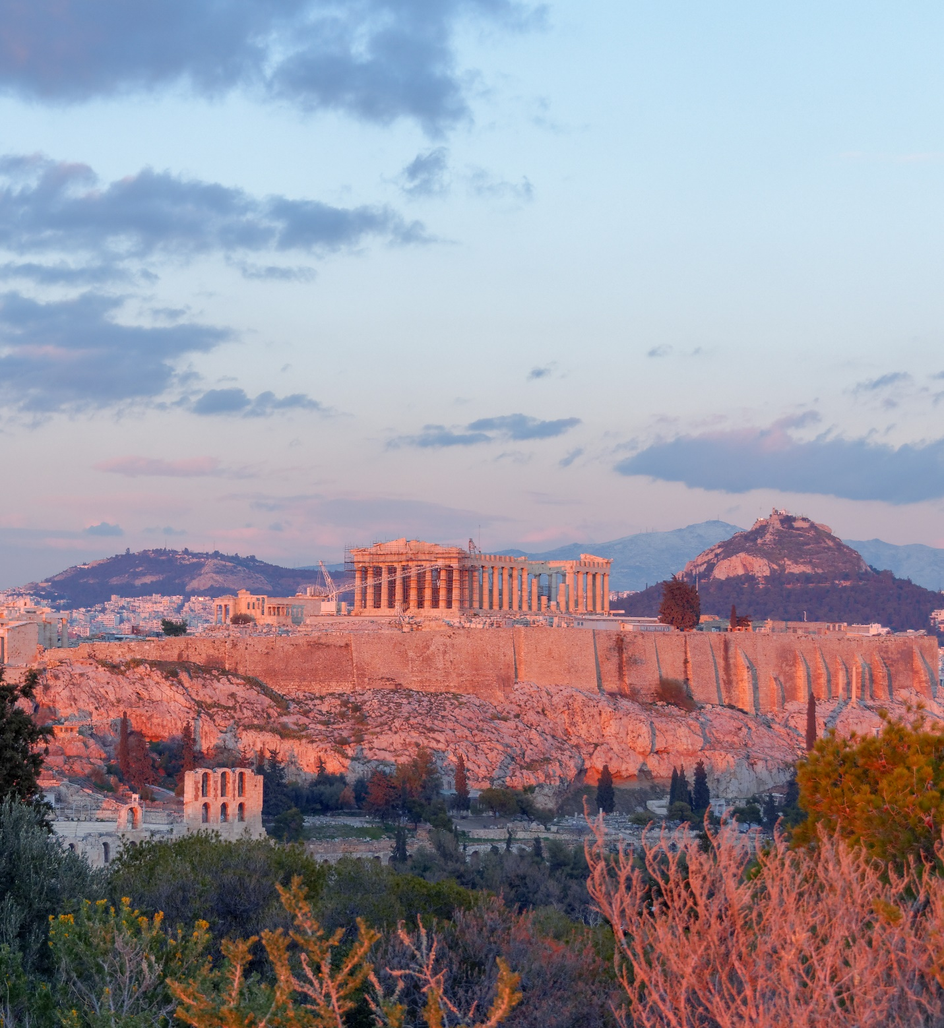
Turkey and Greece
Study Tour
December 27, 2022 – January 12, 2023

The Master’s University
Led by Dr. Todd Bolen

Total Cost: $4,350
Applications available in the Bible Office
For more information, visit www.masters.edu/turkey
Turkey and Greece Study Tour 2022–23
The Master’s University
Led by Dr. Todd Bolen

See the New Testament come to life! Travel to important sites on all three of Paul’s missionary journeys in Acts as well as all seven churches in Revelation. Explore the cities that received Paul’s letters of 1–2 Corinthians, Galatians, Ephesians, Philippians, Colossians, 1–2 Thessalonians, 1 Timothy, and Philemon. Visit the best historical museums in Istanbul, Athens, Ephesus, and Corinth. Study under excellent teaching from Bible-believing professors and guides.

Dec 27 Tues Depart LAX at 3:05 pm on Lufthansa 457.
Dec 28 Wed Arrive at Frankfurt at 11:00 am. Depart at 1:00 pm on Lufthansa 1298. Arrive at Istanbul at 6:05 pm. Transfer to hotel.
Dec 29 Thurs Tour Istanbul, including the Hagia Sophia, Blue Mosque, hippodrome, and Archaeological Museum. Evening flight to Konya (biblical Iconium).
Dec 30 Fri Visit Derbe, Lystra, Iconium, and the Konya Archaeology Museum. Overnight in Konya.
Dec 31 Sat Visit Pisidian Antioch and Archaeology Museum. Drive to Antalya (biblical Attalia) for overnight.
Jan 01 Sun Happy New Year! Visit Perga and Attalia. Drive to Pamukkale for overnight.
Jan 02 Mon Visit Hierapolis, Laodicea, and Colossae. Overnight in Pamukkale.
Jan 03 Tues Visit Philadelphia, Sardis, Thyatira, and the agora of Smyrna. Overnight in Izmir (biblical Smyrna).
Jan 04 Wed Drive to Ephesus to see the impressive ruins of the ancient city. Visit St. John’s Basilica and the Ephesus Museum. Overnight in Izmir.
Jan 05 Thurs Visit Pergamum acropolis and Asclepion. Visit Assos. Overnight in Assos.
Jan 06 Fri Visit Troas and Troy. Cross the Dardanelles. Cross the border into Greece. Overnight in Kavala (biblical Neapolis).
Jan 07 Sat Visit Neapolis, follow Paul’s footsteps on the Via Egnatia, and visit Philippi. Drive past Amphipolis and Apollonia on our way to visit Thessalonica. Overnight in Thessaloniki.
Jan 08 Sun Visit the Archaeological Museum of Thessalonica, the city of Berea, and the famous monasteries of Meteora. Overnight in Kalambaka.
Jan 09 Mon Visit Delphi, home of the famous oracle. Tour the Delphi Museum. Overnight in Athens.
Jan 10 Tues Visit the site of Corinth, including the agora and the museum. Visit Mycenae. Overnight in Athens.
Jan 11 Wed Spend the day in Athens, touring the acropolis, Mars Hill, and the agora. Enjoy some free time for exploring or souvenir shopping. Overnight in Athens.
Jan 12 Thurs Depart Athens at 6:10 am on Lufthansa 1757. Arrive at Munich at 7:45 am. Depart at 12:15 pm on Lufthansa 452. Arrive at LAX at 3:25 pm.

INCLUDED TOUR FEATURES:
- Flights from LAX to Istanbul, Istanbul to Konya, and Athens to LAX
- Sightseeing as per the itinerary
- Daily breakfasts and dinners
- Transportation by private bus
- English speaking professional tour guides
- All entry fees to the sites & museums
- Portage at hotels
- Tips to the hotel and restaurant staff
- Greece border crossing
- Tips to the tour guides and drivers
- Service charges & local taxes

TURKEY HOTELS (9 Nights):
- 1 Night at 4-star Arcadia Blue Hotel www.hotelarcadiablue.com
- 2 Nights at Konya Anemon Hotel www.anemonhotels.com
- 1 Night at 4-star Best Western Khan Hotel in Antalya www.khanhotel.com or similar
- 2 Nights at 4-star Doga Thermal Hotel in Pamukkale www.dogathermalhotel.com or similar
- 2 Nights at 4-star Moevenpick Hotel in Izmir http://www.movenpick.com/en/europe/turkey/izmir/hotel-izmir/overview or similar
- 1 Night at Assos Kervansaray Hotel in Assos www.assoskervansaray.com or similar

GREECE HOTELS (6 Nights):
- 1 Night at Esperia Hotel in Kavala www.esperiakavala.gr or similar
- 1 Night at El Greco Hotel in Thessaloniki http://www.hotelelgreco.gr or similar
- 1 Night at Amalia Hotel in Kalambaka or similar
- 3 Nights at Acropolis Select Hotel in Athens https://acropoliselect.gr or similar

EXCLUDING:
- Turkish Visa Fee to be obtained online before arrival www.evisa.gov.tr ($50 per person for US citizens)
- Lunches and drinks
- Travel and health insurance
- Any Covid-related expenses
- All personal expenses

